**ESO-208A**

**Computational Methods in Engineering**

**Assignment 4**

**2022-23 Semester-1**

**Rishi Kachhwaha**

**200793**

**Q1.**

**a)Romberg Integration :**

**Input :**

exp(-x)

0

1

0.01

**Output :**

I : 0.63212088

Number of intervals : 4

Approximate relative error : 0.0021

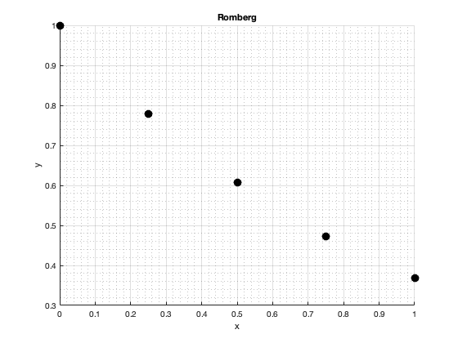

**b)** **Gauss-Legendre quadrature:**

**Input :**

exp(-x)

0

1

0.01

**Output :**

I : 0.63212056

Number of intervals : 3

Approximate relative error : 0.000048

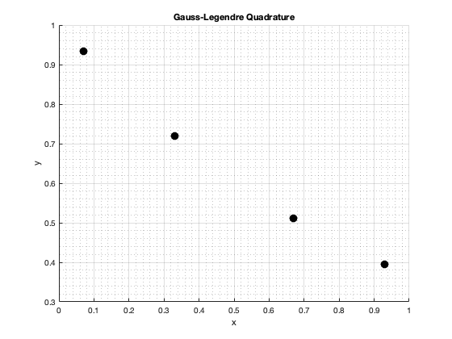

**Q2.**

**a)** **Euler Forward method:**

**Input :**

-y^2*x

0

1

1

0.1

**Output :**

x y

0.00000000 1.00000000

0.10000000 1.00000000

0.20000000 0.99000000

0.30000000 0.97039800

0.40000000 0.94214783

0.50000000 0.90664213

0.60000000 0.86554213

0.70000000 0.82059234

0.80000000 0.77345632

0.90000000 0.72559754

1.00000000 0.67821328

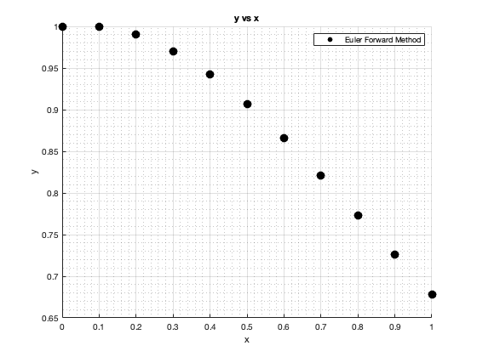

**b)** **2nd order RK method:**

**Input :**

-y^2*x

0

1

1

0.1

**Output :**

x y

0.00000000 1.00000000

0.10000000 0.99500000

0.20000000 0.98034566

0.30000000 0.95687849

0.40000000 0.92586818

0.50000000 0.88885072

0.60000000 0.84745758

0.70000000 0.80326685

0.80000000 0.75769490

0.90000000 0.71193330

1.00000000 0.66692618

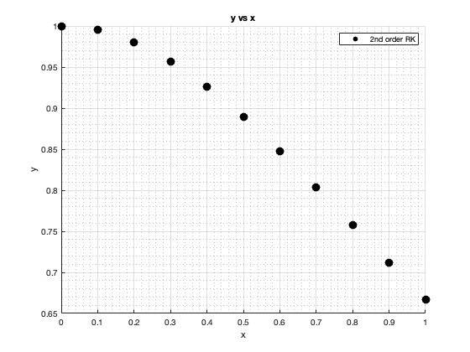

**c)** **4th order RK method:**

**Input :**

-y^2*x

0

1

1

0.1

**Output :**

x y

0.00000000 1.00000000

0.10000000 0.99502487

0.20000000 0.98039212

0.30000000 0.95693772

0.40000000 0.92592580

0.50000000 0.88888872

0.60000000 0.84745744

0.70000000 0.80321267

0.80000000 0.75757561

0.90000000 0.71174366

1.00000000 0.66666661

